April Newsletter
It has been a short month in school because of the Easter break but there is still a lot to share! Here is some of the latest news.
Confirmation – Big congratulations to all the 6th class boys and girls who received the Sacrament of Confirmation with Fr. Brendan on Saturday 2 April in St. Colmcille’s Church, Ballinahown. It was a lovely day for the children and their families. Well done to all!
First Holy Communion – The girls in 2nd Class will receive their First Holy Communion on Saturday 21 May at 2pm in St. Colmcille’s Church, Ballinahown. They are all putting in great effort preparing with Ms. Mollen.
Easter Chicks – There was huge excitement in Ms. Farrell’s room for the weeks before the Easter holidays. The boys and girls watched over the eggs in the incubator for three weeks until they began hatching! Junior and Senior Infants made sure all the chicks and ducklings had enough to eat and drink for the week they were in school. There was great ‘egg-citement’! Thanks to Ronan and Caroline for all their help and the ‘grown up’ chicks and ducklings will come back to visit soon.
Gaelic Football Teams – Well done to both the Boys and Girls Football teams who had wins in the group stages of the Cumann na mBunscoil competitions recently. It is great to see so many girls and boys from 3rd – 6th class represent the school so well! Best of luck to both teams in their matches next week.
- Girls Football – Tullamore Educate Together vs Rashina in O’Brien Park Tullamore at 12.45pm on Thursday 5 May.
- Boys Football – Rashina vs Mountbolus in Doon at 3.15pm on Thursday 5 May.
Literacy Lift Off – Junior and Senior Infants started a four week block of Literacy Lift Off this week. The boys and girls move from station to station working on new reading, familiar reading, phonics, handwriting and ICT. 6th class will work on big books and comprehension with the class next week. Fantastic work on display from the infants.
Walk Tall Programme – The Walk Tall programme will be delivered to all classes starting next week. This programme is part of the SPHE curriculum. An information letter will go home to parents next week.
School Garden –Ms. Mollen’s pupils planted potatoes, strawberries and lots of vegetables with the help of Ms. Guinan and work experience student Chelsea. The bird nest box in our garden is full of the blue tit’s eggs! The mammy is busy protecting them.
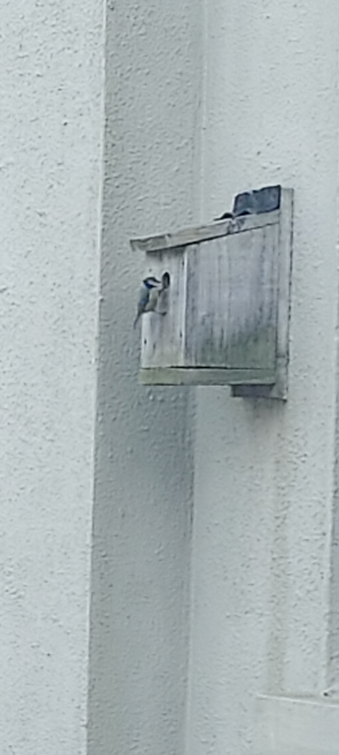
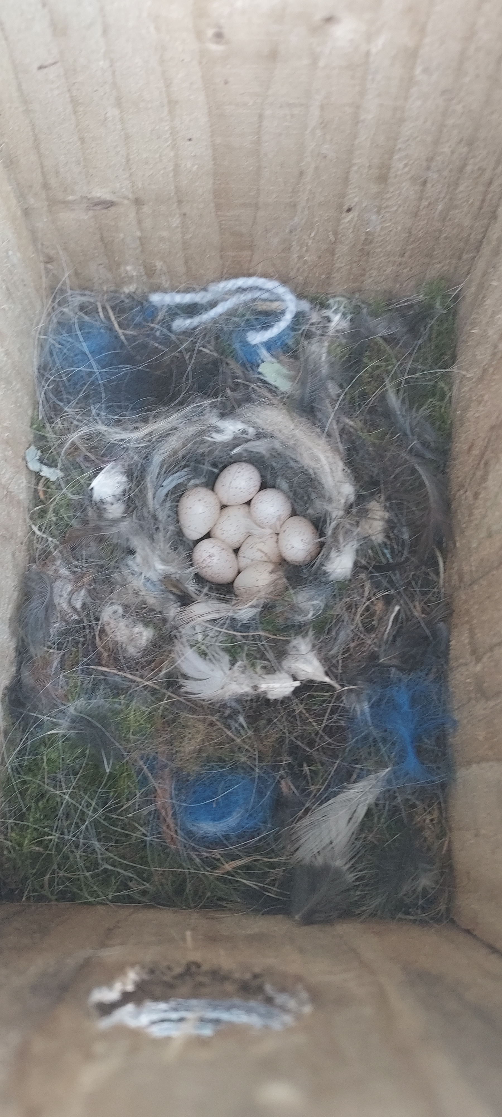

VEX Robotics – Ms. Moran’s class will go to O’Connor Park, Tullamore next Friday 6 May to the Offaly Robotics competition.
Clothes Collection – There will be a Clothes Collection here at the school next Thursday 5 May. These collections have proven to be great fundraisers for the school in the past. Please share this information with family and friends. All support is greatly appreciated.
Rashina NS Family 5k Fun Run/ Walk – We look forward to welcoming all families, wider community and runners to our Fun Run on Sunday 29 May at 2pm. It will start and finish at the school. Registration begins at 1pm. There will be prizes for first placed woman, man and juvenile. Adults are €10, students €5 and U-13’s free. Thanks to all families who have already returned the sponsorship cards. Funds raised will go towards the day-to-day running of the school. There will be refreshments served on the day!
School Closure – There will be no school on Friday 3 June. We are taking this day in place of the extra bank holiday that was given on March 18.
The staff and BOM would like to wish everyone a lovely May Bank Holiday Weekend and look forward to seeing all pupils back to school on Tuesday 3 May.

