First Confessions – 2nd class pupils received their First Confessions from Fr. Brendan on Wednesday April 21st. The eight boys and girls did brilliantly on the day. Congratulations to all!  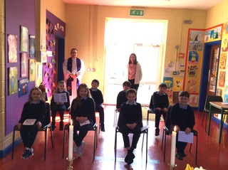  Growing Vegetables – All pupils from 1st to 6th have potted their own vegetables and are looking after them in the classroom. Beetroot, radishes, spinach, peas and more vegetables are growing and will be ready to plant outside soon! More gardening will take place in the coming weeks.  Active Schools Week – This week all pupils incorporated some extra exercise into their week at school and at home. It was lovely to see all classes out working up a sweat in the good weather!  Literacy Lift-Off – Junior and Senior Infants are currently doing great work on their literacy skills each day in Literacy Lift-Off. It is great to see the boys and girls enjoying reading and completing activities. The staff is very happy with their progress.  We will also be commencing Literacy Lift Off in 3rd and 4th class in the coming week.  Uniforms/Labels – Reminder to all families to write their child’s initials or name on label of uniform.  Drop off/ Pick up Times – As you know, the road outside school is very busy in the mornings and afternoons. The safety of everyone is our priority. Thanks to all parents for showing patience and care at these times. | Junior Entrepreneur Programme 2021 – 5th/ 6th classes have been busy developing their business ideas over the past few weeks. There is great imagination and teamwork on show and the boys and girls enjoyed safely pitching their business ideas and products to all the pods from other classrooms today. The boys and girls hope to sell products in the coming weeks. More details soon!  Stay Safe Programme – The Stay Safe Programme is being covered in all classrooms. Thanks to all parents for discussing topics with pupils and signing relevant worksheets.  Sunscreen – Thankfully the weather has been quite nice since Easter and the sun will hopefully continue to shine for the next few months. Parents are encouraged to apply sunscreen on their child before school on such days and put a bottle in their bag for the remainder of the school year.  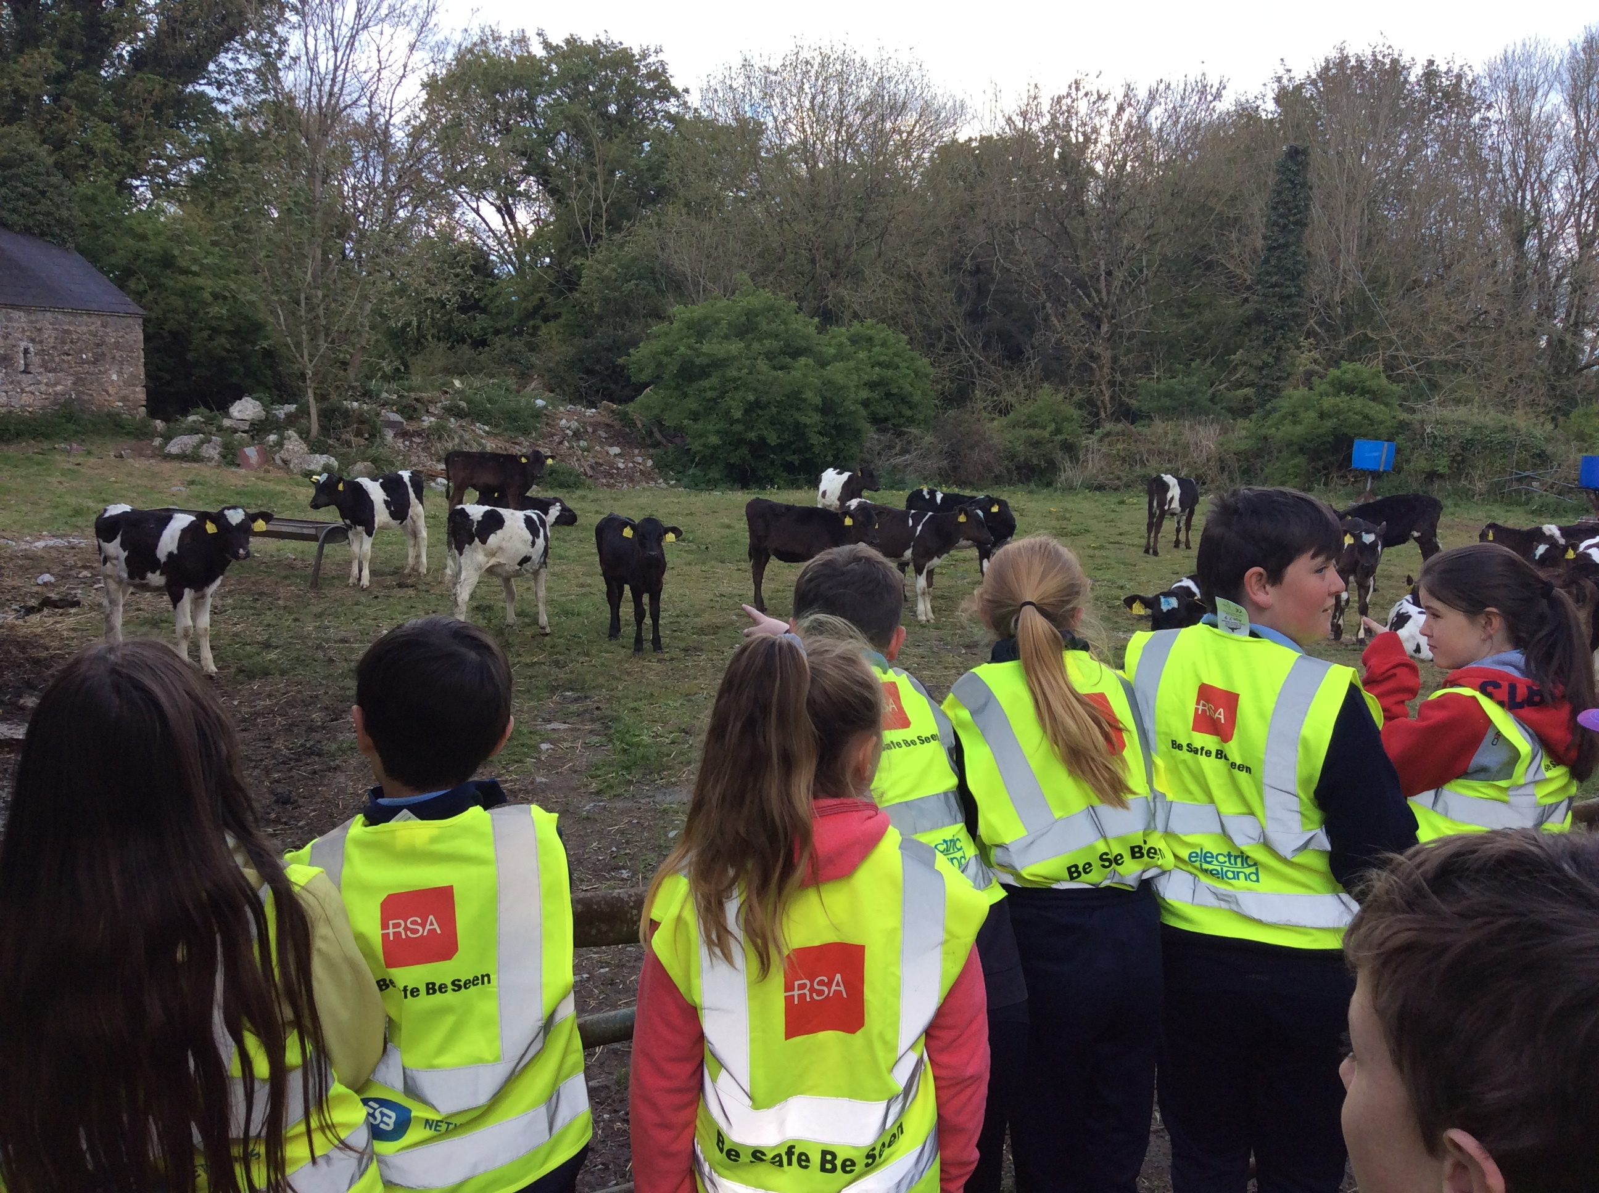  Nature Walks – Pupils from 1st to 4th class enjoyed short nature walks this week. The boys and girls enjoyed identifying the local flora and fauna.  May Altars – With May being the month of Mary, we are going to create a May Altar in each class. Children are encouraged to pick a small bunch of flowers from their gardens and bring them to school next week.  First Holy Communion/ Confirmation Dates – There are no dates set for the sacraments yet. Families will be notified once these dates are confirmed. Well done to all children on their preparation and efforts in school and at home.

