Remote Learning - Thanks to all the students and parents for their engagement in remote learning through Seesaw and Zoom over the past few months. 3rd - 6th class pupils will continue to work this way until school fully reopens.  ICT - The Board of Management has invested in two new Smartboards (Ms. Mollen and Ms. Farrell’s rooms) and 16 new iPads and trolley, which can travel between all classrooms. These additions to ICT will benefit all pupils.  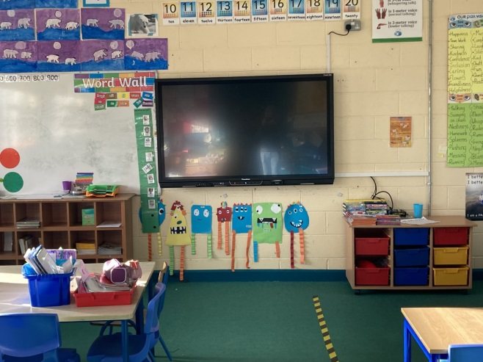  Perspex Screens - To help ensure the health and safety of all, the school has fitted Perspex screens around all teacher/SNA stations.  World Book Day - Thursday, March 4th marks World Book Day. We hope you enjoy reading books and completing some fun activities. Book Tokens will be given to all pupils in school.  Enrolment for Junior Infants - Enrolment for September 2021 remains open and you can request a form from the office. | Spring Has Sprung - Some of the daffodils that were planted by pupils before Christmas are already in full bloom.  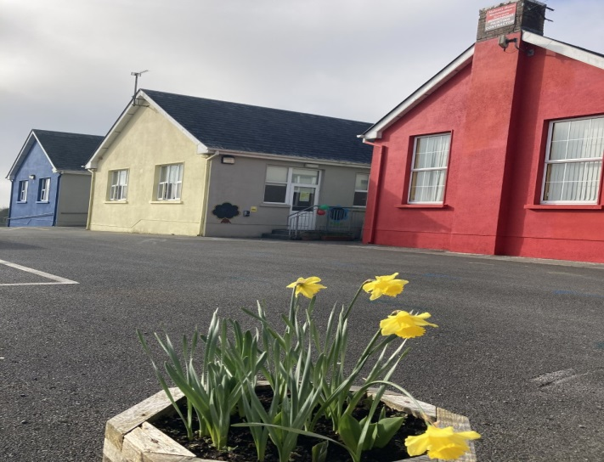  Catholic Schools Week and St. Brigid - Well done to all the students for doing great work at home for these two events.  Sacramental Classes - 2nd and 6th classes are busy preparing for First Holy Communion and Confirmation later in the year.  Midlands Simon Community - We received a lovely letter thanking the school for the donation from the Christmas raffle.  Drop Off/ Collection Times - These are busy times outside our school. Please take extra care in your cars during these times

