Fun Day - All classes enjoyed our Fun Day on June 16th. Highlights from the day included the art activities with Aidan Byrne, the Supermac’s delivery and, of course, the ice-cream van visit!  Sports Week - Boys and girls enjoyed lots of fun activities during the week of June 14th - 18th. It was lovely to see all classes playing games on the court and Astroturf in the sunshine.  Offaly Hospice Donation - 5th and 6th class made a very generous donation of €576 to Mary Murphy from Offaly Hospice on June 17th. Well done all!  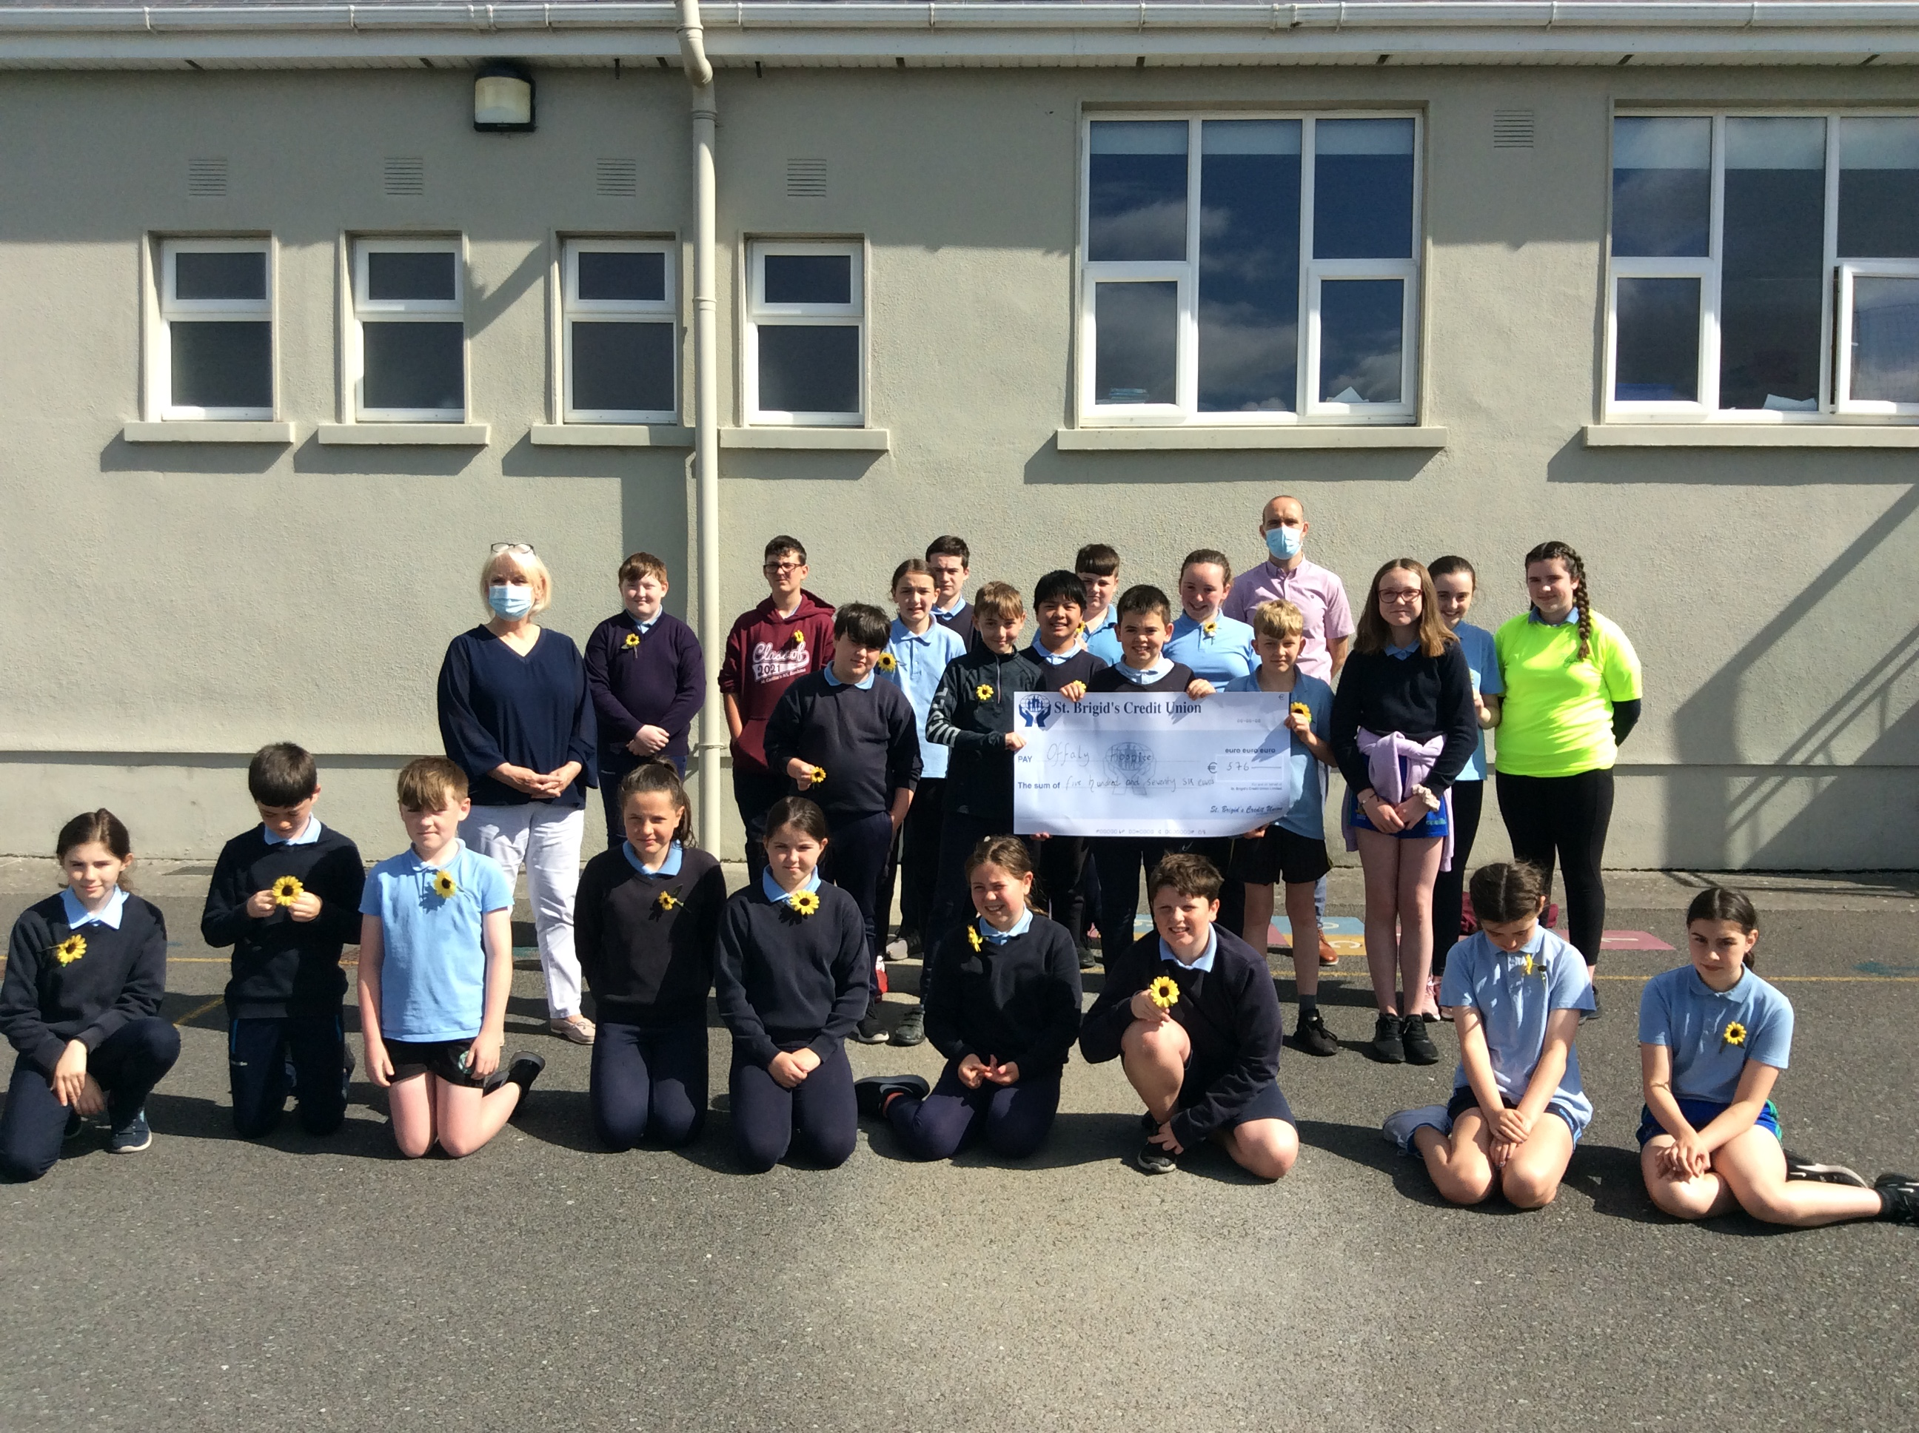  6th Class Graduation 2021 - Congratulations to the boys and girls on graduating from primary school. Thanks very much for all your contributions over the last 8 years and best of luck with everything in the future! Each child enjoyed Graduation cake with a cup of tea and took a lovely photo frame home today. There is a link to a nostalgic 6th class photo slideshow on the website!  School Reports - All families should have received the end-of-year school reports. Well done to all children on their work during the year. | Confirmation - 6th class look forward to Confirmation in Ballinahown on Friday, July 9th at 11am. As part of their preparations, the boys and girls attended Sunday morning mass in Ballinahown.  First Holy Communion - Communion will take place on Sunday, September 5th at 11.30am mass in Ballinahown.  Road Safety Authority - Nicola, from the RSA, gave a very interesting and informative talk about road safety to all classes through Zoom on Monday, June 21st. We got lots of useful safety tips!  Stay Safe - The Stay Safe was completed by all classes during Term 3. Thanks to parents for discussing the topics during homework and returning the signed sheets.  Book Lists - Your child’s Book List has been sent home today. It is also on the school website. We encourage parents to avail of the school’s Book Rental scheme as this will help save money, especially in the older classes.  Junior Infants 2021 - The staff was delighted to meet next year’s Junior Infant class last week during scheduled visits for each child and parent.  School Year 2021/22 - School reopens for all pupils on Tuesday, August 31st at 9am. Next year’s school calendar has been sent home today and is available on the school website.  As a staff, we would like to thank all our pupils for their efforts during the school year. The mixture of both in-school and remote learning this year was challenging and we would like to thank all families for their support throughout the year. We would like to wish all pupils and their families a very safe and enjoyable summer.

