SEN resources and ideas…. 18th May 2020

Fine Motor Skills:
- Working with playdough making shapes, letters, etc.
- Making letters/patterns in sand.
- Popping bubble wrap
- Linking paper clips to make chains, shapes and patterns. | 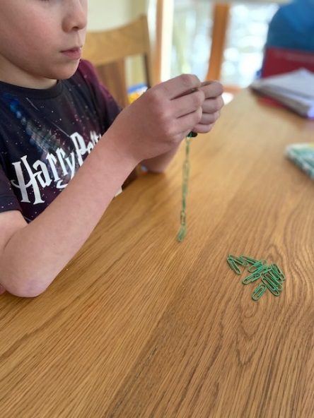
- Using a hole punch to create patterns in paper.  - Fold paper twice and punch holes. Unfold to see the pattern created. | 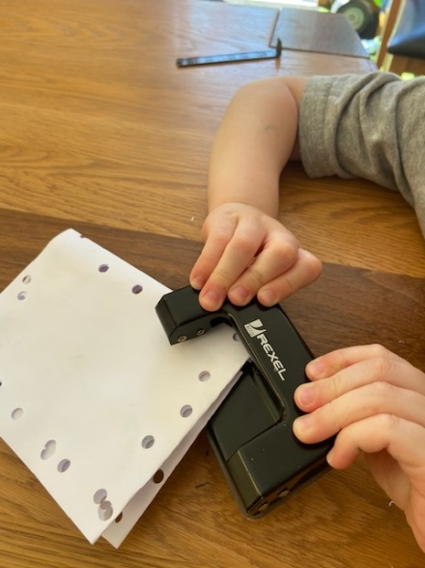

Please see attached documents for further activities on Fine Motor Skills.

Scissors Skills:
Using a scissors is a very important skill to practice:
- If you have a safety scissors at home, your child could cut out 2D shapes to make shapes pictures.
- Cut out pictures from magazines or catalogues to create their own collage or scene.
- See further downloadable activities on scissor activities.

Handwriting/Letter formation:
- Practice with playdough, tracing in sand
- Practice letters on chalk/white boards.
- Use handwriting practice apps for tablets: eg Letter Quiz Lite (practice lower case letters first)

Literacy:
The My Read at Home Book series develops reading fluency and comprehension skills by encouraging daily and independent reading. The series consists of six books: My Read at Home Book 1 – 6 (First class to Sixth class).
Pick whatever level your child feels comfortable reading and read one page daily.
My Read at Home Book series is available on cjfallonaccess
Select Level primary, Class (select class level suitable for your child’s reading level) Subject English, Series, My Read at Home Title My Read at Home Book.
You will need to enter your name, email and click parent to access for the first time.

For Reading comprehension there are many available to download on twinkl, copy and paste the following link:
https://www.twinkl.ie/search?term=reading+comprehension
There are also sample Reading Comprehension Activities in documents attached that you can chose from.

Spelling
SNIP is a programme aimed at increasing reading and spelling for students with Dyslexia. You can choose the level /session appropriate for your child
http://www.snip-newsletter.co.uk/pdfs/downloads/literacy_programme_1.pdf
http://www.snip-newsletter.co.uk/pdfs/downloads/literacy_programme_part_2.
pdf
http://www.snip-newsletter.co.uk/pdfs/downloads/literacy_programme_part_3.
Pdf

Maths:
- Continue to practice tables on a regular basis using recall as well as online resources on topmarks (hit the button) and multiplication.com
- Use the link below for multiplication or division quiz. How many can you do correctly in 1 minute?
https://coolsciencelab.com/math_magician.html
https://coolsciencelab.com/math_magician_division.html

- Time Tables card draw
Equipment: Timer and pack of cards
Remove the picture cards from the deck. Ask your child to turn over cards and multiply the number on the card by the number you are practicing that week when the timer starts. Set the timer for 2 mins and start it. Count how many cards your child managed to collect. Repeat the game twice more and encourage your child to
try and increase the number of cards that they get.

- Dice roll
Equipment: two dice
Your child rolls one die and multiplies the answer by the number that you are practicing that day. When your child has done this successfully for a few minutes, use two dice.

- Use lego/ bricks/ crayons to create multiplication/ division sentences and write the sentences below. | 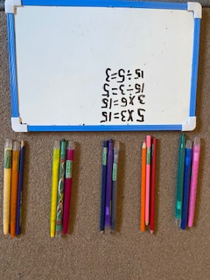

- Investigation on activity on Capacity available on folder.

Wellbeing and mindfulness activities
- This journal below is free to download and aims to help enhance your child’s mental wellbeing during these strange times. You can download it and print it out for your child/children or, if you don’t have access to a printer, your child can get the activity idea from the screen and do it on a blank sheet of paper. https://www.otb.ie/wp-content/uploads/2020/04/At-Home-with-Weaving-Well-being-A-Mental-Health-Journal-for-Kids.pdf
- This pdf below suggests some breathing exercises for children which can be done daily.
https://www.mindfulmazing.com/wp-content/uploads/2019/07/12-Mini-Mindities.pdf
- For some mindful colouring activities twinkl has many themed activities.
https://www.twinkl.ie/search?term=mindfulness%20colouring

Meditation:
https://www.louiseshanagher.com/guidedmeditations

PE:
Cosmic Kids https://www.youtube.com/user/CosmicKidsYoga
PE with Joe https://www.youtube.com/watch?v=Rz0go1pTda8
We hope that we can get outside and play in the garden as much as possible. These are some exercise ideas for when it is raining.
Please see attached folder for gross motor skills activity pack and yoga cards for children.

Project Work:
- Scoilnet have access to world book online which has information on different countries, animals as well as geography and history topics.
https://www.scoilnet.ie/

More websites:
https://classroommagazines.scholastic.com/support/learnathome.html
https://www.natgeokids.com/ie/
https://www.dkfindout.com/uk/

Organisational Skills:

- Children can create their own daily timetable (3rd class upwards) or checklist so that they can keep track of their written activities, project work, learning how to tidy up their own bedroom. See the pdf attached which can be recreated depending on your child/children’s age.
- https://www.familyeducation.com/printables/behavior-checklists-charts-printables/printable-clean-your-room-checklist-kids

Sample Daily Timetable:
9.00- 10.00 | Written activties: Handwriting, English- Grammar, Spellings, Mental Maths and Table Activities.
10.00 -10.30 | Outside play, 10@10, Joe Wicks Go Noodle,  Scavenger Hunts
10.30 – 11.00 | Creative Writing- Narrative, report writing free writing
11.00- 12.00 | Snack Time/ Home School Hub
12.00 – 12.45 | Maths activity online, maths book- new topic,  practical maths using measures, shape hunts.
12.45 – 1.30 | Lunch time and play time outside/ inside
1.30 -2.00 | Gaeilge – ag caint, cula ceathar, abair liom online, Léigh sa bhaile
2.00 – 2.30 | Project work History, Geography or Science: research topics online and record information.
2.30 – 3.00 | DEAR time
3.00 – 3.30 | Art activity, games, puzzles, listen to music, create using bricks or lego.

General Resources:
https://www.twinkl.ie/resources/specialeducationalneeds-sen

Scavanger hunts are a fun break from written activities. These can be inside our outside. There are more available on twinkl:
https://www.twinkl.ie/search?term=outdoor+scavenger+hunt

